Name:__________________________________________________ Date Application Completed: __________________

Date Received: _____________________ Assignment: ______________

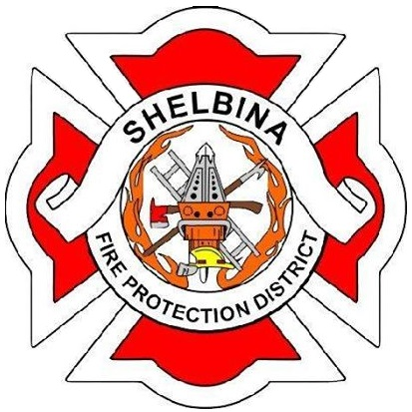

SHELBINA FIRE PROTECTION DISTRICT

MEMBERSHIP
APPLICATION

Shelbina Fire Protection District
204 West Chestnut
Shelbina, Missouri 63468
PERSONAL INFORMATION

Name_______________________________________________________________ Date of Birth___________________
(Last) (First) (M.I.)

Address___________________________________________________________________________________________
(Street) (City) (State) (Zip)

Years at present address?______ If less than 2 years at present address, list previous address:

__________________________________________________________________________________________________
(Street) (City) (State) (Zip)

Home Phone _____________________________ Work Phone ______________________________

Single ________________ Married _________________ Spouse’s Name _______________________________________

Spouse’s employer __________________________________________________________________________________
(Name) (Phone)

Driver’s License Number ____________________________________ Date of Expiration __________________________

Have you ever received a moving traffic violation? ______________ Yes ________________ No
List any: ___________________________________________________________________________________________

Have you ever been convicted of a criminal offense? ______________ Yes ________________ No
List any: ___________________________________________________________________________________________

Do you own a vehicle? ______ Yes ______ No ___________________________________________________________
(Year) (Make) (Model) (Condition)

Automobile Insurance Carrier __________________________________________________________________________
(Company) (Agent) (Coverage/limits of liability)
EDUCATION

Circle the highest grade completed: 6 7 8 9 10 11 12 13 14 15 16
HIGH SCHOOL | VOCATION/TRADE SCHOOL | COLLEGE/UNIVERSITY
NAME:
CITY/STATE:
YEAR GRADUATED:
AREA/DEGREE/DIPLOMA:
MILITARY

BRANCH: | HIGHEST RANK: | DATES: | ASSIGNMENT:
RELATED EXPERIENCE

Have you ever served on a fire district/department? _____________ Yes ____________ No

If yes, list district/department _________________________________________________________________________
(Name) (City/State) (Phone #) (Chief Officer)

List previous fire service training _______________________________________________________________________
__________________________________________________________________________________________________
__________________________________________________________________________________________________

Do you hold a current Missouri EMT license? ____________ If yes, ____________________________________________
License Number Exp. Date
Do you hold a current Missouri Paramedic license? _______ If yes, ____________________________________________
License Number Exp. Date
List any other fire service/EMS/rescue related training ______________________________________________________
__________________________________________________________________________________________________
List any specialized equipment you have experience in operating. Include trucks, heavy equipment, etc. ______________
__________________________________________________________________________________________________
EMPLOYMENT

EMPLOYER/ADDRESS/DATES POSITION/SUPERVISOR REASON YOU LEFT
(Current employer first)

What are your current hours? ___________________ Would you be able to respond from work? ______ Yes _____ No
ORGANIZATIONAL AFFILIATIONS/HOBBIES/INTERESTS

List any organizations you are affiliated with ______________________________________________________________
__________________________________________________________________________________________________
List any hobbies or special areas of interest _______________________________________________________________
__________________________________________________________________________________________________
__________________________________________________________________________________________________
Do you know anyone who is currently serving with the Shelbina Fire Protection District? _____ Yes _____ No
If so, Who? ________________________________________________________________________________________
HEALTH

Height ________________ Weight _______________ Condition of Health ______________________________________
Have you ever been treated for medical problems involving: (check) ______ Back ______Heart ______ Respiratory
Have you ever been treated by a physician for any condition in the past three years? _____ Yes _____ No
If yes, please describe ________________________________________________________________________________
__________________________________________________________________________________________________
__________________________________________________________________________________________________
Have you been hospitalized in the past three years? _____ Yes _____ No
If yes, please describe ________________________________________________________________________________
__________________________________________________________________________________________________
__________________________________________________________________________________________________
In your opinion, do you have any condition (physical or mental) that may adversely affect your performance as a firefighter in any way? _____ Yes _____ No
If yes, please describe ________________________________________________________________________________
Have you had a complete physical within the past 2 years? _____ Yes _____ No
Family Physician ____________________________________________________________________________________
(Name) (Address) (Phone)
REFERENCES

List three local references you have known for at least two years. Do not list relatives or former employers.
Name/Address | Day Phone/Evening Phone | How long have you known?
ADDITIONAL INFORMATION

How did you learn of the Shelbina Fire Protection District? __________________________________________________
Why do you wish to become a member of this organization and why do you feel you would be an asset to the organization? ______________________________________________________________________________________
__________________________________________________________________________________________________
__________________________________________________________________________________________________
CONSENT/SIGNATURE

I certify that all information contained within this application is true to the best of my knowledge. I understand that the Shelbina Fire Protection District will verify all information contained within this application and perform the following reference checks: drivers license record check and background investigation.

_________________________________________________ _____________________________
Applicant’s Signature Date

Social Security # __________________________________
Please attach a copy of your driver’s license, high school diploma or GED, and verification of auto insurance to this application.

